Manually create an environment variable in a solution
- Sign in to Power Apps (make.powerapps.com), and then on the left pane select Solutions. If the item isn’t in the side panel pane, select …More and then select the item you want.
- Open the solution you want or create a new one.
- On the command bar, select New > More, and then select Environment variable.
- On the right pane, complete the following columns, and then select Save:
  - Display name. Enter a name for the environment variable.
  - Name. The unique name is automatically generated from the Display name, but you can change it.
  - Data Type. Select from Decimal number, Text, JSON, Two options, Data source, or Secret.
- Current Value. Also known as the value. This property is optional and is a part of the environment variable value table. A defined value is used even if a default value is also present. Remove the value from your solution if you don't want to use it in the next environment. The values are also separated into separate JSON files within the exported solution.zip file and can be edited offline. More information: How do I remove a value from an environment variable?
- Default Value. This column is part of the environment variable definition table and isn't required. The default value is used if there's no current value.
Separation of default value and current value allows you to service the definition and the default value separately from the value. For example, an application publisher might list their offer on Marketplace with a default value. Then optionally, the customer can provide a new value. When the application publisher publishes updates to the application, the value set by the customer isn't overwritten.
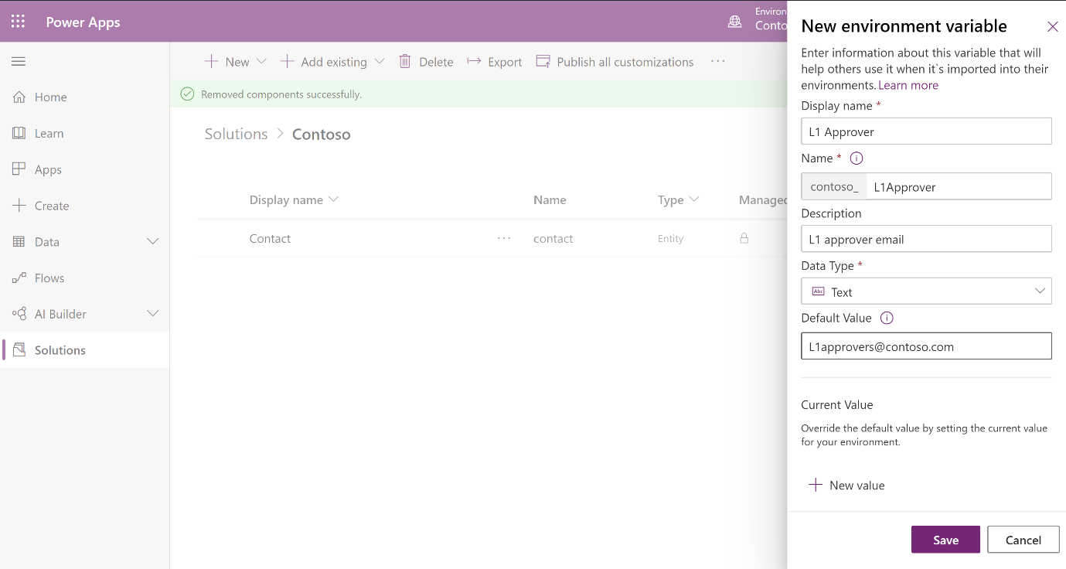

Power Apps can automatically create environment variables
On the General tab of Power Apps settings:
- Enable the Automatically create environment variables when adding data sources option. Now, when you add a new data source to your app, it adds an environment variable for you.


